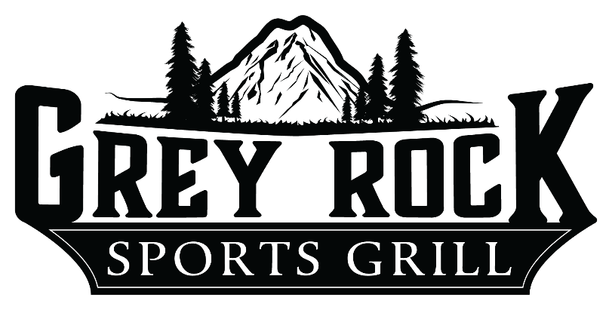

Group Information

Menus and Beverage Services
Grey Rock Sports Grill menus and beverage information are enclosed for your consideration. Beverages for your function will be based on consumption. Please note that all food and beverage prices quoted are subject to gratuity and applicable sales tax.

Reservation Information
Grey Rock Sports Grill is great for any type of gathering. Our relaxed atmosphere and great food make us a local favorite. If you choose a buffet, we ask that you provide the final guaranteed guest count 72 hours prior to the function. The guarantee is not subject to reduction. Final billing will be based on the guarantee or the actual number of guests, whichever is greater.

Buffet and Party Menus
Prices are per person. Menus are not all-you-can-eat, but are portioned appropriately to your guest count. Soft Drinks are included. Prices do not include tax or gratuity. Buffets require a minimum of 20 people.

Sampler Buffet
Choose any three of the following items
Buffalo Dunked Tenders
(or other sauce of your choice)
Fried Pickles
Santa Fe Egg Rolls
Potato Skins
Chicken and Cheese Quesadillas
Steakhouse Onion Rings
Jalapeno Bottlecaps
Chocolate Chip Cookies
add $1 per person for each additional item
$13
Fiesta Buffet
Chips and Salsa
Homemade Guacamole
Tortillas and Taco Shells
Spiced Chicken and/or Beef
Black Beans, Tomato, Cheese, Lettuce and Sour Cream
Sopapillas
$14

Tailgate Buffet
Angus Beef Hamburgers
French Fries
Coleslaw
Includes all the trimmings: cheese, lettuce,
tomato, onions and pickles
Chocolate Chip Cookies
$15

The Best Barbecue
Pulled Pork with Buns
Barbecue Chicken Breasts
Mashed Potatoes
Coleslaw
Onion Rings
Chocolate Chip Cookies
$15

Pizza Buffet
Assorted Pizzas
Cheese Curds
Breadsticks
Caesar Salad
Sopapillas
$15

All American Buffet
Chicken Fried Chicken
Mashed Potatoes with Country Gravy
Seasoned Corn
House Salad
Breadsticks
Chocolate Chip Cookies
$16

Mix and Match
Any of our great appetizers, pizzas and wings for your group.
Pre-order a few and add as you go. Great for any group, large or small.

Santa Fe Egg Rolls
Black beans, chicken, cheese, onions, jalapenos, red peppers, corn and spices
Potato Skins
Shredded cheddar cheese and bacon with green onions
Grey Rock Sampler Platter
Combination of Chicken Tenders, Buffalo Wings, Mozzarella Sticks, Onions Rings and Fries.
Macho Team Nachos
Fresh Corn Tortilla Chips smothered in cheddar, black beans, jalapenos, green chilis, diced tomatoes and green onions.
Topped with chicken or beef.
Wings & Dunked Tenders
100 meaty chicken wings. Choose three of your favorite sauces.
Carolina Gold Buffalo Bangkok Chili Chipotle BBQ
Spicy Garlic Inferno Teriyaki Sweet & Tangy BBQ

Big Team Sampler
Buffalo Wings, Boneless Buffalo Bites, Wisconsin Cheese Curds, Mozzarella Sticks, Pickle Fries, and a couple onion rings on top of a mountain of fries.

Chili Con Queso Dip
A blend of our homemade green chili and cheddar cheese with just the right amount of kick! Served with fresh corn tortilla chips.

Specialty Pizzas
Hot, fresh, homemade
Double Pepperoni ∙ Meat Lovers ∙ Combination ∙ Fresh Garden Veggie ∙ Hawaiian ∙ Buffalo Chicken ∙ Greek

